**Evaluating the effectiveness of intensive OHV reclamation activities to recover native trout along the East Slopes of Alberta, Canada.**

J.Reilly 2018

Intensive OHV reclamation activities and reductions in public motorized access have been initiated in Alberta to support native trout recovery. “Intensive” efforts are defined as those improving >50% of highly degraded trout habitat. Roni *et al*. ([2010](https://onlinelibrary-wiley-com.login.ezproxy.library.ualberta.ca/doi/full/10.1111/fme.12077#fme12077-bib-0042)) suggested that extensive restoration is required to deliver measurable changes in fish abundance such that restoring 20% of a degraded stream was required to achieve a 25% increase in smolt production for coho salmon; 100% of the habitat would need to be restored to be 95% certain of achieving a 25% increase in smolt production. In Alberta, three watersheds are targeted for remediation: Rocky Creek, Fall Creek, and Mackenzie Creek. It is the goal of Alberta Environment and Parks to monitor fish populations in these watersheds and detect if the reclamation activities resulted in a measureable change to the density of immature and adult fish, particularly bull trout.

Rocky Creek – 20 km of reclaimed trail, 31 crossing remediated (XX% of watershed), removal of motorized access

Fall Creek – 12 km of reclaimed trail, 50 crossing remediated (XX% of watershed), removal of motorized access

Mackenzie Creek - TBD

# Hypotheses (Immediate, 1-3 years)

**Hypotheses (null)**: Extensive OHV reclamation activities did not result in a measureable increase of immature or adult bull trout at the population level.

This may occur if: 1) bull trout are limited by other key factors (e.g., brook trout, whirling disease, high angling mortality); 2) reclamation activities were not significant enough to produce a detectable change in the population; 3) there is a longer time lag between reclamation, habitat improvement, and population response.

**Hypotheses (alternate):**

* Extensive OHV reclamation activities result in an increase of immature bull trout at the population level, because of improvements to spawning, nursery, and rearing habitat and reduced destruction/disturbance of redds.
  + Target: increase of immature density (single pass CUE) by 1 FSI category (200% change).
* Extensive OHV reclamation activities result in an increase of adult bull trout at the population level, because of reduction of motorized public access and subsequent reduction in angling mortality.
  + Target: increase of adult density (single pass CUE) by 1 FSI category (200% change).

# Hypotheses (Short-term, 4-6 years)

**Hypotheses (null)**: Extensive OHV reclamation activities did not result in a measureable increase of immature or adult bull trout at the population level.

This may occur if: 1) bull trout are limited by other key factors (e.g., brook trout, whirling disease, high angling pressure); 2) reclamation activities were not significant enough to produce a detectable change in the population.

**Hypotheses (alternate):**

* Extensive OHV reclamation activities result in an increase of immature bull trout at the population level, because of improvements to spawning, nursery, and rearing habitat and reduced destruction/disturbance of redds.
  + Target: increase of immature density (single pass CUE) by 1 FSI category (200% change).
* Extensive OHV reclamation activities result in an increase of adult bull trout at the population level, because of reduction of motorized public access and subsequent reduction in angling mortality, and increased survival of juvenile fish.
  + Target: increase of adult density (single pass CUE) by 1 FSI category (200% change).

# mBACI Study Design

A multiple Before-After-Control-Impact (mBACI) approach will be used. This approach consists of investigating a subset of projects implemented across the East Slopes using a before-after control-impact sampling design. This replication may allow AEP to understand why some projects are more successful than others. The major advantage of the mBACI approach is that it allows for both evaluation of individual projects and analysis of all projects to determine the overall effectiveness of an entire restoration program. In addition, it is replicated through time and can allow for examination of trends through time and, potentially, both short and long-term responses. A properly implemented BACI design is considered the best for environmental monitoring (Underwood 1991; Stewart-Oaten and Bence 2001).

# Scale

Treatment and control watersheds will be at the HUC 10 or 12 watershed scale because immature and mature trout move and use habitats throughout a watershed. In the absence of movement information, this scale is assumed to roughly estimate the spatial extent of resident bull trout and Athabasca rainbow trout populations; however, some individuals may stray, producing a meta-population structure (see limitations).

# Treatment and Control Watersheds

1. Control watersheds need to have similar conditions to the impacted watersheds (i.e., similar in geomorphology (channel width, type, gradient), flow, land use, and riparian condition). (O’Neal et al 2016)
   * Rocky Creek -3 controls selected with similar characteristics (Table 1 and 2), within same HUC 8 watershed ✓.
   * Fall Creek – no controls available within HUC 8 watershed because bull trout either extremely low density, extirpated, or not historically present in nearby watersheds X
   * Mackenzie Creek – 2 controls selected with similar characteristics (Table 3 and 4). Moon Creek is within the same HUC 8 watershed and Athabasca drainage. No other similar watersheds within the Athabasca drainage. Thistle Creek is not in the same HUC 8 watershed and in North Saskatchewan drainage (but just over divide and similar elevation). ✓?
2. Control sites remain adequate controls through time (Roni 2018) and are not influenced by the remediation activities (O’Neal et al 2016)
   * Rocky Creek – 3 controls selected for contingency because restoration activities may take place in the near future in Cutoff Creek ✓
   * Fall Creek – no controls available X
   * Mackenzie Creek – No restoration activities or other major changes expected in Moon and Thistle Creek ✓
3. The use of multiple controls avoids the criticism that the results of the BACI experiment are solely due to a poor choice of control sites (Underwood, 1992, Swartz 2015)
   * Rocky Creek – 3 controls ✓
   * Fall Creek – no controls available X
   * Mackenzie Creek – 2 controls ✓

# Variables

Choose multiple response variables for the species of interest (Bennet 2016). By measuring multiple metrics at multiple spatial and temporal scales, there is an increased chance of detecting a response and determining the causal connection between the restoration action and ultimate change in fish productivity (Bennet 2016).

* + We will measure single-pass CUE and record FL of all species captured ✓

# Pre- and post- impact sampling frequency and intensity

Pre-impact sampling:

1. Ideal is 3 years of data, minimum is 1 (Smokorowski et al. 2015). Power and sample size estimates indicate that two or more years of pre-impact data are necessary to adequately determine the effectiveness of many project types, particularly for fish (O’Neal 2016) (Table 5).
   * Rocky Creek – 2 years pre-impact, but all historical and not consecutive years
   * Cutoff Creek – 3 years pre-impact, but 2 yrs historical, not consecutive years, not same years as Rocky
   * Limestone – 1 year pre-impact, but historical, not same year as Rocky
   * Fall Creek - 3 years pre-impact, but 1 yr historical, not consecutive years
   * Mackenzie- 4 years pre-impact, 2 years being historical and not consecutive years
   * Moon- 6 years pre-impact, 4 years being historical and not consecutive years
   * Thistle - 3 years pre-impact, 1 year being historical and not consecutive years

Post-impact sampling:

1. Blocks of continuous monitoring after the impact provide more robust conclusions (avoids mimicking a natural cycle; better to estimate process error). Recommends data collection in pulses of 3 years (Smokorowski et al. 2015).
   * We will monitor continuously for 5 years (Table 5) ✓
2. Collect immediate, short-term, and long-term data to capture trends and lagged responses (Smokorowski et al. 2015).
   * Only planning on immediate and short-term monitoring. Long-term monitoring dependant on results and funding ✓

# Number of sites

* Rocky Creek – pending power analysis
* Fall Creek
  + power analysis based on trend detection (not BACI design) analysis developed by Swartz in 2017
  + TBD
* Mackenzie Creek – pending power analysis

# Placement of sites

Sites will be places using GRTS **OR** sites will overlap historical sites in cases where previous sampling designs included random placement of sites. If previous design includes additional sites, GRTS will be used to select a sub-set.

# Analysis

(Pending assistance from C. Swartz)

* T-test (This approach is best suited for indicators that exhibit either stepwise change or change in a dramatic fashion over a short period of time (O’Neal 2016)). Change in immature/adult FSI category is target measure (~200% change).
* BACI ANOVA (This approach is best suited for indicators that exhibit either stepwise change or change in a dramatic fashion over a short period of time (O’Neal 2016)). Change in immature/adult FSI category is target measure (~200% change).
* Trend analysis (This approach is best suited for indicators that change slowly through time but are on a distinct trajectory of change O’Neal 2016)). Consider this for immature and adult CUE – not sure how quickly the population may respond. Expect adult CUE to respond slower. (trend different than zero).

# Limitations

The study watersheds likely contain resident and migratory bull trout populations. The survival of large, migratory fish is influenced by factors outside the HUC 10 and 12 study areas (e.g., fishing mortality). Therefore, the response to OHV reclamation may be under- or over-estimated should there be changes outside of the treatment and control watersheds that effect the survival of large, migratory fish.

## Clearwater River watershed

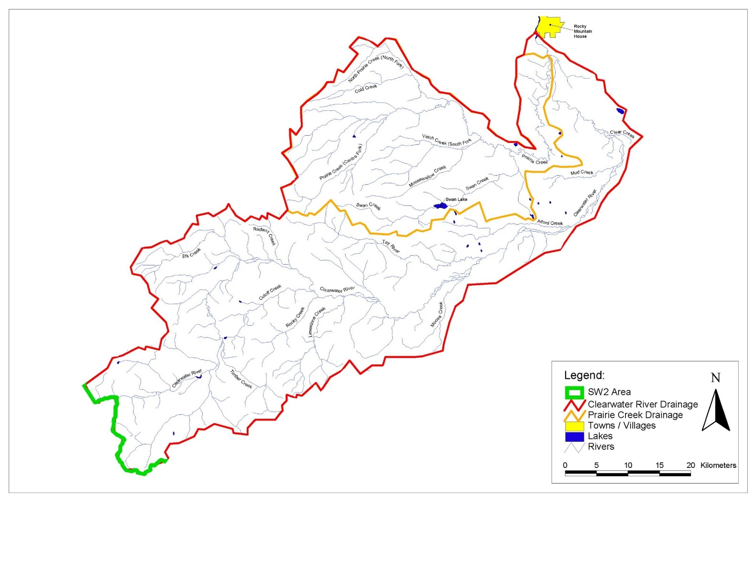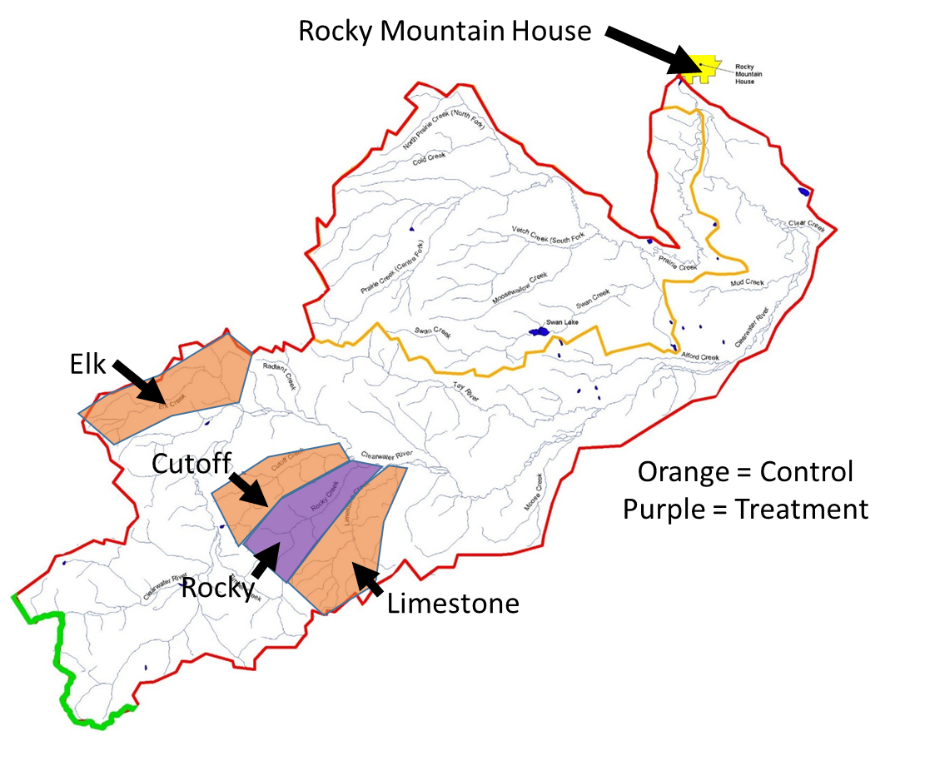

Figure 1. General study area showing treatment and control watersheds within the Clearwater River watershed.

Table 1. Characteristics of treatment and control watersheds within the Clearwater River watershed.

## 

Table 2. Bull trout catch-per-unit-effort and previous sampling record in treatment and control watersheds within the Clearwater River watershed.



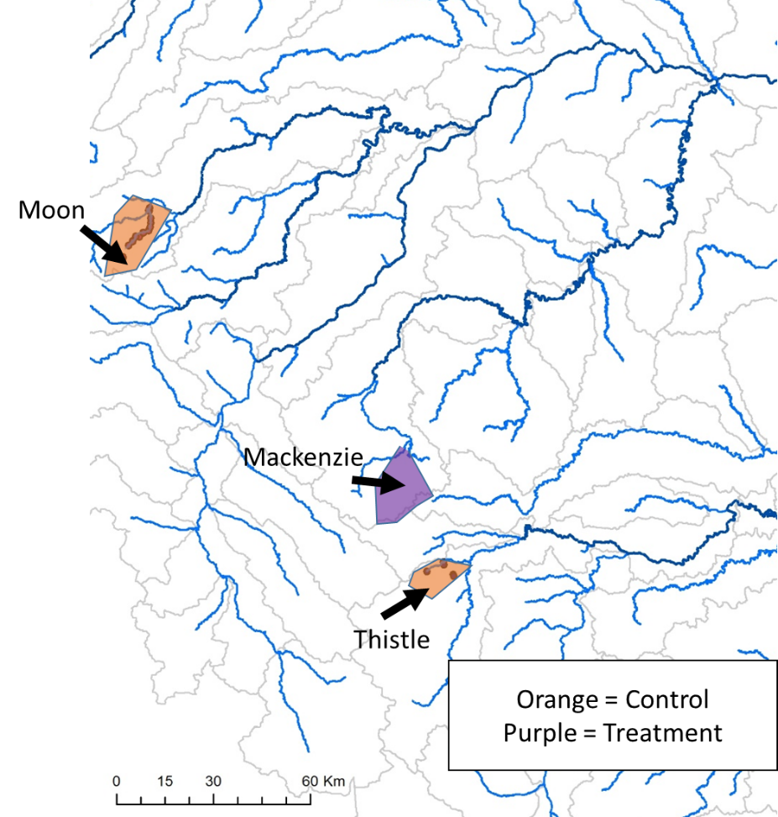

Figure 2. General study area showing treatment and control watersheds within the Athabasca and North Saskatchewan River watersheds.

Table 3. Characteristics of treatment and control watersheds within the Athabasca and North Saskatchewan River watersheds.



Table 4. Bull trout catch-per-unit-effort and previous sampling record in treatment and control watersheds within the Athabasca and North Saskatchewan River watersheds.



Table 5. Historical sampling frequency and proposed monitoring schedule.

